# Restore the Search Function in Compass

Process

Related Documents

**Description:** Steps to restore the Search tab in Compass.

|  |
| --- |
| Process |

Did you lose your **Search** tab in Compass?

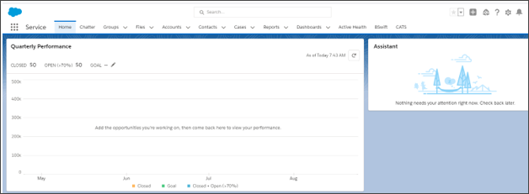

If your Compass screen looks like the screen above, or any other screen besides the search screen, you need to get back to the Compass **Search** screen in order to service incoming calls.

Follow the below steps:

|  |  |
| --- | --- |
| **Step** | **Action** |
| **1** | Click on the **App Selector** (aka the **9 box**) icon in the top left corner. |
| **2** | When the drop down appears, click on **View All**, or type in PHD in the drop-down. |
| **3** | Select **Compass**.    **Result:** The **Member Search Console** appears. |

Top of the Document

|  |
| --- |
| Related Documents |

**Parent Document:**  [CALL 0049 Customer Care Internal and External Call Handling](https://policy.corp.cvscaremark.com/pnp/faces/DocRenderer?documentId=CALL%200049)

Top of the Document

Not to Be Reproduced or Disclosed to Others without Prior Written Approval

**ELECTRONIC DATA = OFFICIAL VERSION / PAPER COPY = INFORMATIONAL ONLY**